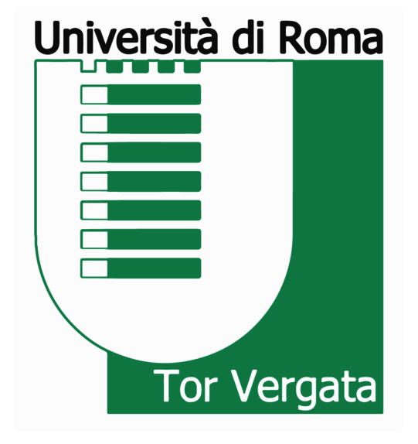

ECBSM 2022

Instructions for Abstract Submission

The abstracts can ONLY be submitted to the e-mail address patrick.di-martino@cyu.fr.

Submission Deadline: September 23, 2022

Language of Abstract: All abstracts must be submitted in English and must be proofread for grammar and spelling before submission.

Limit on Number of Submissions: A maximum of one abstract submission per presenter. A participant can be included in more than one submission as a co-author.

Abstract Description:
- Limits on the number of words: 150 to 200 words.
- The title: The font must be Times New Roman, 12 points, boldfaced, single-spaced, and all capital letters. The title should be concise, yet specific
- List of authors and affiliations: Provide the full names (Times New Roman, 12 points) and affiliations (Times New Roman, 11 points) of all the authors. The affiliations should include the department or the laboratory, the university or the organization, the city, and the country. One of the authors should be designated as the corresponding author with an asterisk, and his/her email address must be included.
- The body: The font must be 11-point Times New Roman and the number of words should be between 150 and 200. The abstract should be written in a form of a paragraph and briefly outline the main features, results, and conclusions with their general significance. Citations, charts, tables, figures, and graphs should not be included in the abstract.
- Keywords: The font should be 11-point Times New Roman with a limit of 4 to 6 words.
Presenting Speaker:
Submission of an abstract constitutes a commitment by the submitter to present a communication (oral or poster).
The oral presentation can be carried out both in presence and online; the poster session is only in presence.
Please indicate the requested presentation format (oral or poster) in your email accompanying the submission of your abstract and if you will participate in presence or online.

Accepted Abstracts: An email will be sent to the Abstract Submitter by September 2022 with the result of the abstract review (accepted or rejected) and the presentation format (oral or poster). The presenting speakers will be required to register with the Congress by October 7, 2022, to confirm their inclusion in the Congress Program and the Book of Abstracts. Accepted authors who do not register by the deadline will not be included in the Congress Program or the Book of Abstracts.

